201533661 이승수

**<input>**

1st line: number of vertex

Else: fromVertex toVertex weight

**<code>**

#include <stdio.h>

#define INF 1000

distance[100][100] = { 0 };

int vertexNum;

FILE *inF, *outF;

int distanceDijkstra[5] = {0};

void main()

{

inF = fopen("input.txt", "r");

fscanf(inF, "%d", &vertexNum);

for (int i = 0; i < vertexNum; i++)//initialize

{

distanceDijkstra[i] = INF;

for (int j = 0; j < vertexNum; j++)

{

distance[i][j] = INF;

}

}

while (feof(inF) == 0)

{

int from, to, Distance;

fscanf(inF, "%d %d %d", &from, &to, &Distance);

distance[from - 1][to - 1] = Distance;

}

fclose(inF);

for (int j = 0; j < vertexNum; j++)//put the distance from index s to distanceDijkstra for first looping

{

if (distance[0][j] != INF)

distanceDijkstra[j] = distance[0][j];

printf("%d ",distanceDijkstra[j]);

}

printf("\n");

for (int v = 0; v < vertexNum; v++)

{

for (int u = 0; u < vertexNum; u++)

{

if (distanceDijkstra[v] > distanceDijkstra[u] + distance[u][v])// relaxation

{

distanceDijkstra[v] = distanceDijkstra[u] + distance[u][v];

for (int k = 0; k < vertexNum; k++)

printf("%d ",distanceDijkstra[k]);

printf("\n");

}

}

}

outF = fopen("output.txt", "w");

for (int i = 0; i < vertexNum; i++)

{

fprintf(outF,"%d ", distanceDijkstra[i]);

}

fclose(outF);

}

**<step of array distanceDijkstra>**

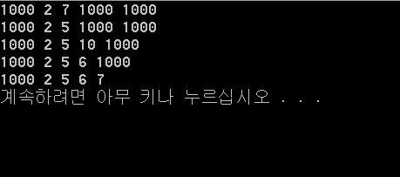

**<output>**

**Final distanceDijkstra array**